2503A52664

Task Description #1 (Privacy &amp; Security in File Handling)
Task: Use an AI tool to generate a Python script that stores user data (name, email, password) in a file.
Analyze: Check if the AI stores sensitive data in plain text or without encryption.
Expected Output:
Identified privacy risks.
Revised version with encrypted password storage (e.g., hashing).
Prompt;
Generate a Python script to store name, email, and password in a file. Identify privacy risks of plain-text password storage and provide a safer version using password hashing.
Code;

import hashlib
import json
import secrets
from getpass import getpass
from hmac import compare_digest
from pathlib import Path

PLAIN_TEXT_FILE = Path("users_plaintext.json")
SECURE_FILE = Path("users_secure.json")
HASH_ALGORITHM = "PBKDF2-HMAC-SHA256"
HASH_ITERATIONS = 600_000
SALT_BYTES = 16

def save_user_plaintext(name: str, email: str, password: str,
file_path: Path = PLAIN_TEXT_FILE) -> None:
"""Unsafe example: writes the password exactly as entered."""
user = {"name": name, "email": email, "password": password}
file_path.write_text(json.dumps(user, indent=2), encoding="utf-8")

def hash_password(password: str, salt: bytes) -> str:
"""Return a slow, salted password hash suitable for storage."""
password_bytes = password.encode("utf-8")
password_hash = hashlib.pbkdf2_hmac(
"sha256", password_bytes, salt, HASH_ITERATIONS
)
return password_hash.hex()

def save_user_secure(name: str, email: str, password: str,
file_path: Path = SECURE_FILE) -> None:
"""Store identity data, a random salt, and a one-way password hash."""
salt = secrets.token_bytes(SALT_BYTES)
user = {
"name": name,
"email": email,
"password_hash": hash_password(password, salt),
"salt": salt.hex(),
"algorithm": HASH_ALGORITHM,
"iterations": HASH_ITERATIONS,
}
file_path.write_text(json.dumps(user, indent=2), encoding="utf-8")

def verify_password(password: str, file_path: Path = SECURE_FILE) -> bool:
"""Check a password without storing or comparing the original text."""
user = json.loads(file_path.read_text(encoding="utf-8"))
salt = bytes.fromhex(user["salt"])
candidate_hash = hash_password(password, salt)
return compare_digest(candidate_hash, user["password_hash"])

def explain_plaintext_risks() -> None:
"""Print the privacy and security problems with plaintext storage."""
print("Plaintext password storage risks:")
print("- Anyone who reads the file immediately gets the real password.")
print("- Backups, logs, malware, or accidental file sharing can expose it.")
print("- People often reuse passwords, so one breach can affect other accounts.")
print("- Administrators and developers may see credentials they do not need.")

def main() -> None:
explain_plaintext_risks()
print("\nCreate a user (the secure version is used by default).")
name = input("Name: ").strip()
email = input("Email: ").strip()
password = getpass("Password: ")

save_user_secure(name, email, password)
print(f"Saved user data to {SECURE_FILE}.")
print(f"Password check: {verify_password(password)}")
print("\nImprovements: the password is never written to the file, each user gets")
print("a random salt, and PBKDF2 makes password guessing more expensive.")
print("The file still needs operating-system access controls and encryption")
print("for highly sensitive deployments.")
"""Store user credentials and demonstrate why password hashing matters.

The plaintext function is included only to show the unsafe original design.
The secure function is the one used by main().
"""

if __name__ == "__main__":
main()
output;

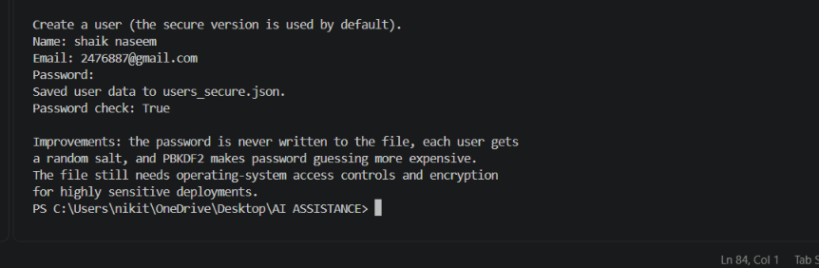
TASK 2:
Task: Prompt an AI tool to generate a scholarship eligibility checker based on academic score,
family income, and location. Examine whether the logic unfairly favors or disadvantages any
group.
Expected Output-2:
Code snippet with observations on fairness.
Brief explanation (3–4 sentences) suggesting improvements to ensure equitable decision-
making.
PROMPT;
Generate a Python scholarship eligibility checker using academic score, family income, and location. Check the code for unfair bias and suggest improvements for fairness.
Code;
from dataclasses import dataclass

@dataclass(frozen=True)
class EligibilityResult:
eligible: bool
score_points: int
income_points: int
location_points: int
total_points: int
reasons: tuple[str, ...]

# Use documented, consistently applied thresholds rather than subjective review.
MIN_ACADEMIC_SCORE = 80.0
MAX_FAMILY_INCOME = 60_000.0
REQUIRED_POINTS = 70

# This must be based on independently verified hardship data and reviewed often.
# Unknown locations receive no penalty and can still qualify through other factors.
LOCATION_HARDSHIP_POINTS = {
"high_need": 20,
"moderate_need": 10,
"standard": 0,
}

def check_eligibility(
academic_score: float,
family_income: float,
location_category: str,
) -> EligibilityResult:
"""Evaluate published criteria and return an auditable decision."""
if not 0 <= academic_score <= 100:
raise ValueError("academic_score must be between 0 and 100")
if family_income < 0:
raise ValueError("family_income cannot be negative")

category = location_category.strip().lower()
location_points = LOCATION_HARDSHIP_POINTS.get(category, 0)
score_points = min(60, round(academic_score * 0.6))
income_points = 30 if family_income <= MAX_FAMILY_INCOME else 0
total_points = score_points + income_points + location_points

reasons = []
if academic_score < MIN_ACADEMIC_SCORE:
reasons.append("academic score is below the published minimum")
if family_income > MAX_FAMILY_INCOME:
reasons.append("family income is above the published threshold")
if category not in LOCATION_HARDSHIP_POINTS:
reasons.append("location category was not recognized; no location bonus applied")
if total_points < REQUIRED_POINTS:
reasons.append("total points are below the published threshold")

return EligibilityResult(
eligible=(academic_score >= MIN_ACADEMIC_SCORE and total_points >= REQUIRED_POINTS),
score_points=score_points,
income_points=income_points,
location_points=location_points,
total_points=total_points,
reasons=tuple(reasons) or ("all published criteria were met",),
)

def fairness_review() -> tuple[str, ...]:
"""Suggested safeguards for deployment and periodic bias checks."""
return (
"Validate thresholds with outcome data and test selection rates across demographic groups.",
"Do not collect or use protected traits for scoring; use them only, where lawful, for aggregate bias auditing.",
"Justify location categories with current, public hardship evidence and offer an appeal for incorrect data.",
"Provide accessible application and appeal processes, manual review for edge cases, and clear explanations.",
"Recheck missing-data handling and monitor for disparate impact before changing the rules.",
)

if __name__ == "__main__":
result = check_eligibility(88, 42_000, "moderate_need")
print(result)
print("Fairness improvements:")
for recommendation in fairness_review():
print(f"- {recommendation}")

output:
Task3:

Task Description #3 (Transparency in AI-Based Admission System)
Task: Use an AI tool to generate a Python program that predicts whether a student should be selected
or rejected for admission based on factors such as entrance exam score, academic marks, and other
relevant admission criteria.
Analyze: Check whether the AI system provides a clear and understandable reason for its admission
decision.
Expected Output:
• Identified transparency risks.
• Example of an admission decision where the AI gives no explanation.
• Revised version that provides a clear reason for selecting or rejecting the student.
• Example output showing the important factors that influenced the AI&#39;s decision.
Promt:
Generate a Python admission system using entrance exam score and academic marks. Check if the decision is transparent and provide clear reasons for selection or rejection.
Code:
MIN_EXAM_SCORE = 70.0
MIN_ACADEMIC_MARKS = 65.0
MIN_COMPOSITE_SCORE = 70.0
EXAM_WEIGHT = 0.60
ACADEMIC_WEIGHT = 0.40

@dataclass(frozen=True)
class AdmissionDecision:
selected: bool
composite_score: float
reasons: tuple[str, ...]

def assess_admission(entrance_exam_score: float,
academic_marks: float) -> AdmissionDecision:
"""Return an explainable admission decision from two academic measures.

Both inputs are percentages in the range 0--100. The decision uses only
the stated scores, and the reasons identify every rule that passed or
failed so applicants can understand the result.
"""
for name, value in (("entrance exam score", entrance_exam_score),
("academic marks", academic_marks)):
if not isinstance(value, (int, float)) or isinstance(value, bool):
raise TypeError(f"{name} must be a number")
if not 0 <= value <= 100:
raise ValueError(f"{name} must be between 0 and 100")

composite = (entrance_exam_score * EXAM_WEIGHT
+ academic_marks * ACADEMIC_WEIGHT)
reasons = []

if entrance_exam_score >= MIN_EXAM_SCORE:
reasons.append(
f"Entrance exam score {entrance_exam_score:.1f} meets the "
f"minimum of {MIN_EXAM_SCORE:.1f}.")
else:
reasons.append(
f"Entrance exam score {entrance_exam_score:.1f} is below the "
f"minimum of {MIN_EXAM_SCORE:.1f}.")

if academic_marks >= MIN_ACADEMIC_MARKS:
reasons.append(
f"Academic marks {academic_marks:.1f} meet the minimum of "
f"{MIN_ACADEMIC_MARKS:.1f}.")
else:
reasons.append(
f"Academic marks {academic_marks:.1f} are below the minimum of "
f"{MIN_ACADEMIC_MARKS:.1f}.")

if composite >= MIN_COMPOSITE_SCORE:
reasons.append(
f"Composite score {composite:.1f} meets the minimum of "
f"{MIN_COMPOSITE_SCORE:.1f} ({EXAM_WEIGHT:.0%} exam, "
f"{ACADEMIC_WEIGHT:.0%} academic).")
else:
reasons.append(
f"Composite score {composite:.1f} is below the minimum of "
f"{MIN_COMPOSITE_SCORE:.1f} ({EXAM_WEIGHT:.0%} exam, "
f"{ACADEMIC_WEIGHT:.0%} academic).")

selected = (entrance_exam_score >= MIN_EXAM_SCORE
and academic_marks >= MIN_ACADEMIC_MARKS
and composite >= MIN_COMPOSITE_SCORE)
reasons.insert(0, "Selected." if selected else "Rejected.")
return AdmissionDecision(selected, round(composite, 2), tuple(reasons))

def main() -> None:
"""Read scores and print a transparent decision and its reasons."""
try:
exam = float(input("Entrance exam score (0-100): "))
marks = float(input("Academic marks (0-100): "))
decision = assess_admission(exam, marks)
except 0(TypeError, ValueError) as error:
print(f"Invalid input: {error}")
return

print(f"Decision: {'SELECTED' if decision.selected else 'REJECTED'}")
print(f"Composite score: {decision.composite_score:.2f}")
print("Reasons:")
for reason in decision.reasons:
print(f"- {reason}")
Output:

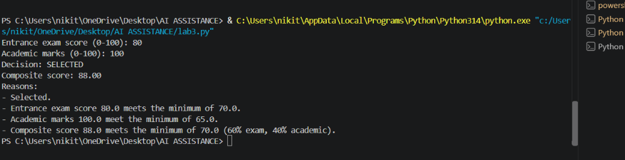
TASK4:
Task Description #4 – Ethical Scoring System

Task: Generate an employee performance evaluation system using inputs such as project
completion rate, teamwork score, and attendance. Analyze the scoring logic for any unethical
weighting or hidden bias.
Expected Output-4:
Python code along with a written analysis identifying whether the evaluation criteria are
balanced and justifiable.
PROMT:

Generate a Python employee performance scoring system using project completion, teamwork, and attendance. Analyze the scoring for unfair weighting or hidden bias and suggest improvements.
CODE:

from typing import Mapping

WEIGHTS = {
"project_completion": 0.40,
"teamwork": 0.35,
"attendance": 0.25,
}

@dataclass(frozen=True)
class EmployeePerformance:
project_completion: float
teamwork: float
attendance: float

def score_employee(
performance: EmployeePerformance,
*,
weights: Mapping[str, float] = WEIGHTS,
) -> float:
"""Return a validated weighted performance score from 0 to 100."""
values = {
"project_completion": performance.project_completion,
"teamwork": performance.teamwork,
"attendance": performance.attendance,
}
if set(weights) != set(values):
raise ValueError("weights must contain exactly the three score fields")
if any(not isinstance(value, (int, float)) for value in values.values()):
raise TypeError("performance measures must be numeric")
if any(not 0 <= value <= 100 for value in values.values()):
raise ValueError("performance measures must be between 0 and 100")
if any(weight < 0 for weight in weights.values()) or sum(weights.values()) <= 0:
raise ValueError("weights must be non-negative and have a positive total")

total_weight = sum(weights.values())
return sum(values[name] * weights[name] for name in values) / total_weight

def fairness_review() -> list[str]:
"""Return risks and improvements for reviewing this scoring approach."""
return [
"Project completion may favor roles with easier deadlines or more resources; compare employees within comparable roles and normalize project scope.",
"Teamwork ratings can contain manager, proximity, or communication-style bias; use behavior-based criteria, multiple raters, and calibration.",
"Attendance may penalize disability, caregiving, illness, approved leave, or remote work; do not treat protected absences as poor performance.",
"Audit score distributions and downstream decisions by relevant groups where lawful, using privacy safeguards and qualified legal review.",
"Publish the rubric, let employees verify inputs and appeal results, document overrides, and review weights regularly for job relevance.",
]

if __name__ == "__main__":
example = score_employee(EmployeePerformance(90, 80, 95))
print(f"Example performance score: {example:.1f}/100")
print("Fairness review:")
for recommendation in fairness_review():
print(f"- {recommendation}")
OUTPUT:
TASK5:
Task Description #5 – Accessibility and Inclusiveness
Task: Use an AI tool to generate a user feedback form application. Review whether the language
and options provided are inclusive and accessible to diverse users.
Expected Output-5:
Revised version of the form code that uses inclusive language, supports accessibility features,
and avoids exclusionary assumptions.
PROMT:
5.Create a simple Python user feedback form that collects basic information and asks users about their experience. Review the form to check whether the language, questions, and answer options are inclusive and accessible to people with different backgrounds and needs. Identify any exclusionary assumptions or limited choices. Then provide a revised version of the code using respectful, inclusive language, flexible options, and accessibility-friendly features.
CODE:

@dataclass
class Feedback:
"""Responses collected by the form."""

name: str
experience: str
rating: str
improvements: str
contact_permission: str

def ask_required(prompt: str) -> str:
"""Ask until the user provides a non-empty response."""
while True:
answer = input(prompt).strip()
if answer:
return answer
print("This question is required. Please enter a response, or type 'skip' if allowed.")

def ask_rating() -> str:
"""Collect an optional, clearly labelled rating."""
options = {"1", "2", "3", "4", "5", "skip"}
while True:
answer = input(
"How would you rate your experience? "
"Choose 1 (very difficult) to 5 (very easy), or type 'skip': "
).strip().lower()
if answer in options:
return answer
print("Please enter a number from 1 to 5, or type 'skip'.")

def collect_feedback() -> Feedback:
"""Display the form and return the user's responses."""
print("\nUser feedback form")
print("You may skip any optional question. Please do not share sensitive information.\n")

name = input("Name or preferred identifier (optional): ").strip()
experience = ask_required(
"What would you like us to know about your experience? "
"(You may type 'skip' if you prefer not to answer): "
)
rating = ask_rating()
improvements = input(
"What could we improve? (optional; use your own words): "
).strip()

while True:
contact_permission = input(
"May we contact you about this feedback? Choose yes, no, or skip: "
).strip().lower()
if contact_permission in {"yes", "no", "skip"}:
break
print("Please enter 'yes', 'no', or 'skip'.")

return Feedback(name, experience, rating, improvements, contact_permission)

if __name__ == "__main__":
feedback = collect_feedback()
print("\nThank you for sharing your feedback.")
print("Your responses were recorded without requiring personal details.")

OUTPUT:

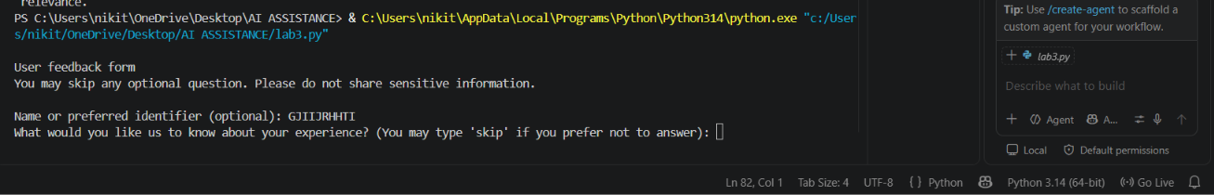
Task6:
Task Description #6 (Fairness in Loan Approval System)
Task: Use an AI tool to generate a Python program that predicts whether a person should be approved or rejected for a loan based on information such as income, age, employment status, credit score, and loan amount.
Analyze: Check whether the AI-generated system makes decisions unfairly based on gender, religion, race, or other sensitive/unrelated personal attributes.
Expected Output:
- Identified fairness and discrimination risks.
- Examples showing how biased data or rules can lead to unfair loan decisions.
- Revised version that makes loan decisions based on relevant financial factors rather than sensitive attributes.
- Brief explanation of how the revised system improves fairness.

Promt:
Write a Python loan approval system using income, age, employment status, credit score, and loan amount. Analyze fairness risks from gender, religion, race, etc., give examples of bias, and provide a revised fair version using only relevant financial factors.
CODE:
class LoanApplication:
"""Financial information needed by this simple demonstration."""

income: float
age: int
employed: bool
credit_score: int
loan_amount: float

def approve_loan(application: LoanApplication) -> tuple[bool, str]:
"""Return a deterministic decision based only on relevant financial data."""
if application.income <= 0 or application.loan_amount <= 0:
return False, "Income and loan amount must be positive."
if not 18 <= application.age <= 100:
return False, "Applicant must be an adult."
if not 300 <= application.credit_score <= 850:
return False, "Credit score must be between 300 and 850."

# These thresholds are illustrative, not a production underwriting policy.
debt_to_income_proxy = application.loan_amount / application.income
if not application.employed:
return False, "Stable employment is required under this example policy."
if application.credit_score < 640:
return False, "Credit score is below the example threshold."
if debt_to_income_proxy > 0.40:
return False, "Requested amount is high compared with annual income."
return True, "Application meets the example financial criteria."

def read_application() -> LoanApplication:
"""Collect only the factors used by the decision function."""
return LoanApplication(
income=float(input("Annual income: ")),
age=int(input("Age: ")),
employed=input("Currently employed? (yes/no): ").strip().lower() == "yes",
credit_score=int(input("Credit score: ")),
loan_amount=float(input("Requested loan amount: ")),
)

if __name__ == "__main__":
try:
application = read_application()
approved, explanation = approve_loan(application)
print("\nDecision:", "APPROVED" if approved else "NOT APPROVED")
OUTPUT:
